# **Visualization Redesign Project Report:** Submitted by Malya Jain

## **Project outline:**

The project consists of redesigning the visualization of Change in the Median Household Incomes from 2007 to 2015. The visualization is already existing on the census.gov website [1]. I wish to redesign and make the visualization more informative.

This visualization would present data on income and poverty in the United States based on information collected from 2007 to 2015 and how it has increased/decreased over the years per state/county.

**Project motivation:**

As the economies continuously grow, it is interesting to note the effect of the income of the citizens of a country. According to news reports[2], there was a record breaking single year increase of 5.2% since 1967. Few reasons can be attributed to this are inflation, employment opportunities, poverty, recession and the change in government. I would further try to analyze the drop in poverty rates based on the employment opportunities created.

**Why I decided to redesign this visualization:**

This graph is very interesting. Here are some key observations one can entail upon looking at this visualization (which proves our general awareness wrong).

* Looking at this visualization, one deciphers that the Median Household Income of the mid-western states like North Dakota, South Dakota, Nebraska, Kansas, Oklahoma, Texas and Montana (cumulatively) has actually increased by a range of 28.5 to 74.7%. Hence, one presumes that these states are best gainers i.e. these states got richer in 8 years.
* On the other hand, the states of California, Arizona, Nevada, Idaho and Oregon are the worst losers (cumulatively) in terms of change in Median Household Income from 2007 – 2015 as the visualization depicts that it has decreased by 8.9-29%.
* Hence, it is okay to presume these states actually got poorer? This contradicts with our general knowledge about which state is the richest and poorest.
* Thankfully, this is not the case. The analysis done basis

**Problems with this visualization:**

* This visualization gives a very deceptive interpretation of the Median Household Income of counties as discussed in the section above
* Analyzing the Median Household Income of counties does not give a comprehensive picture of the states, which is a better scale for analysis
* The scale is small with no labeling, so one can’t accurately get to the point of their county or any other county for that matter

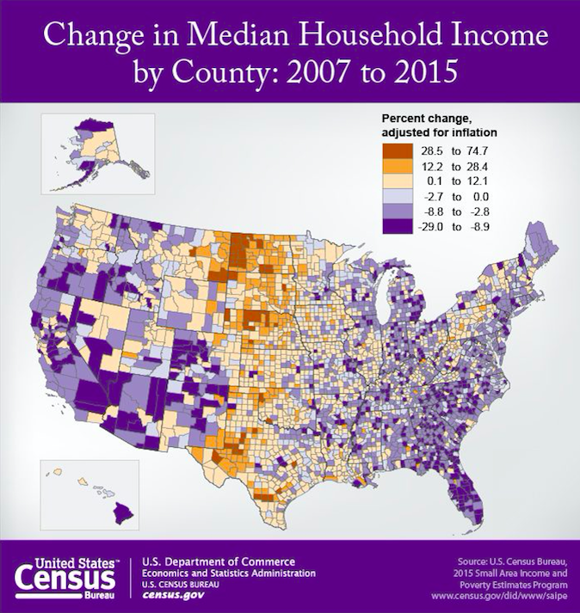

**Fundamental issue with this visualization:**

* Upon carefully analyzing the data behind this visualization, I noted that the percent change in Median Household Income varies because the MHI in 2007 is much below the National Average in 2007 and even if the state showed a 25-30% increase in the change in the MHI, it is still way below the National Average of 2015.
* Hence, this visualization fails to give the clear representation of the richest and poorest state, because percentage change is not a good representation of the analysis. We need to see the starting and the ending income as compared to the National Average for the two years into consideration.

**How I improved and redesigned this visualization:**

* First, I took the analysis of state rather than the counties.
* I have put reference line for the MHI for 2007 i.e.$42,728 and for 2015 i.e. $48,665 so that it is easy to relate to where the state lies with reference to the National MHI.
* I have used a scatter plot with measure values of Average MHI 2007 and Average MHI 2015 per state and plotted them with reference to the National MHI
* I also looked into the data and calculated average for the states rather than counties, because this gives us a better picture of the richest and poorest state
* I have taken into consideration the poverty change rate and population change rates over the sample years 2007 and 2015

**Claim: Change in Median House Income by State: 2007 – 2015 – Which state got richer and poorer?**



**Why I chose this claim – Use Case:**

Lets take the example of the following five states:

|  |  |  |  |  |  |  |
| --- | --- | --- | --- | --- | --- | --- |
| **S. No** | **State** | **MHI 2007** | **Difference from National MHI 2007** | **MHI 2015** | **Difference from National MHI 2015** | **MHI Percentage Change (2007-2015)** |
| 1 | **North Dakota** | $39, 851 | ($2,877) | $56,342 | $7,677 | 44.31% |
| 2 | **Maryland** | $62,743 | $20,015 | $70,210 | $21,545 | 25.76% |
| 3 | **Oklahoma** | $37,687 | ($5,041) | $45,392 | ($3,273) | 24.00% |
| 4 | **California** | $52,844 | $10,116 | $57,593 | $8,928 | 14.35% |
| 5 | **Hawaii** | $61,372 | $18,644 | $62,847 | $14,182 | 3.06% |

North Dakota is the top gainer in the MHI percentage change of 44.31%

However, on careful analysis, it was noted that the starting MHI was actually $2,877 lesser than the National MHI in 2007 and it rose by 44.31% from that.

Maryland is also one of the top most gainer, but note that the MHI 2007 was much higher than the National Average MHI 2007 and even much higher than MHI 2015 for that matter. This means that the starting MHI was so much high but the MHI percent change was actually 20 percent points less than North Dakota.

Oklahoma’s percent MHI change is actually 24% which is only 1 percent point lesser than Maryland, however, note that the MHI 2007 and MHI 2015 were still much lower than National Average MHI.

California always catches our interest because it consists of the Silicon Valley and we are residents of that place. It can be noted that the average change starts from a range much higher than the National Average MHI but still have an relative average change of 14.35%

Last state for analysis is Hawaii. It has the lowest percent change in the MHI, however, note that the MHI difference was $18,644 and $14,182, again much higher than the National Average MHI for 2007 and 2015 respectively.

**Conclusion:** It is clear that the visualization released by the US Census Board doesn’t give a clear picture of the starting and ending points of the MHI and also no comparison with the National MHI.

Looking at the graph one deduces North Dakota is the richest state and Hawaii is the poorest state. Here is why the deduction is wrong and the visualization is deceptive.

North Dakota’s change in MHI was 44.31%; still its MHI in 2007 was so much lesser than the National MHI.

Hawaii’s change in MHI was mere 3.06%; still its MHI in 2007 was much higher than the National MHI for 2007 and 2015 for that matter.

Hence in my graph I wish to show the MHI for 2007 and 2015 with respect to the National MHI and sorted on the basis of the poverty.

**Analysis of the visualization parameters and filters:**

I have kept the claim as same as the one defined by US Census board because the main idea is the same. I have made the following changes:

* Taken change in Median Household Income per State rather than County
* Calculated the Average Median Household Income per State for the years 2007 and 2015
* Created a parameter for Richest States on the percentage change in the MHI from 2007-2015. It is a slider-based parameter on which the end user can see the top states in the MHI
* Created the filter for the average change in population per state
* Created the filter for the average change in poverty per state, which can give an idea on the richest and poorest state
* Finally the states are sorted in decreasing order on the parameter based on the following calculation:

Difference (National Average Median Household Income 2015 and State Median Household Income 2015)

* I have also created the filter for state highlight, so that the user can see the state of choice and where it lies with respect to the other states.

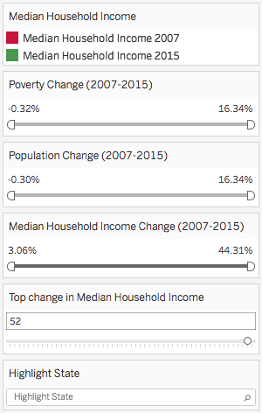

**Project Diary:**

**Failed Visualizations:**













Discussion with professor:

* Not necessary to create an interactive
* 2007 chart – less deviation/variance
* 2015 chart – large increases or decreases
* Same % change over years
* Scatter plot – 2007 and 2015 – doesn’t make sense
* Midwestern states got richer
* % Change is where do they start from
* Financial effect because of recession
* Map it with the population
* The areas with maximum population suffers the most
* % of people have 30% less and 30% and more
* Relate it to number of people
* The existing graph is very deceptive – it shows that the Midwest got richer ??
* California is -29% - very strange
* Maybe the scale has flipped?
* Population per county
* % of people who got richer or poorer

<http://www.otago.ac.nz/wellington/otago054994.pdf>

<http://www.epi.org/publication/lost-decade-poverty-income-trends-continue-2/>

<https://smartech.gatech.edu/bitstream/handle/1853/54223/3161_income_poverty.pdf>

<https://www.ets.org/s/research/pdf/poverty_and_education_report.pdf>

<https://www.census.gov/library/publications/2015/demo/p60-252.html>

<https://www.census.gov/content/dam/Census/library/publications/2016/demo/p60-256.pdf>

<https://www.census.gov/library/publications/2016/demo/p60-256.html>

* When analyzed closely, this shows a very deceptive picture of the change in median income over the years.
* The graph shows that the Midwest and Central America has shows the maximum increase in the change in Median Income from almost 30-70 percent.
* As comparison to the west and east coast which shows that the change in median income has reduced by 8.9 to 29%
* These statistics are not very convincing because we all think that the Midwest and Central American population is very less, so if we think about it, how can the median income raise so much, more than double
* The key here is to identify what is the beginning and ending salary over the years 2007 and 2012
* Upon carefully analyzing the data, I noted the following two figures:
  + California, 2007, MI – 3191827 for 2015, MI - 3356576
  + North Dakota, 2007, MI – 101718 for 2015, MI – 3030517
* As we can see that the MI for North Dakota was much more lower (almost a third) of the median income for CA in 2007 and the drastic increase in the MI is because of the of the oil boom in North Dakota in the year 2006 which showed up its effects till the year 2012.
* <https://en.wikipedia.org/wiki/North_Dakota_oil_boom>
* The oil boom created enough jobs in the state, which had the lowest employment rate in the country.
* Further the population of North Dakota (2007) is only 1,305,644 as compared to the California population of 72,500,622 which is 72 times
* Clearly factors like these were not taken into consideration while creating the graph for the change in median income
* Let us analyze the poverty figures for the two states now
* California 2007 8867133 which was 12% of the total population and for North Dakota it was 312503 which is 24% of the total population
* This definitely means that there is a correlation between not only the poverty and median income but also between population and median income as combined with the poverty.
* Upon looking at multiple research papers and studies I came to the following conclusion
* Data shows that the official poverty rates have decreased by 1.2% in 2015 however, the number of full time year round workers increased by 2015 million.
* All this data has been captured at 90% confidence level
* So that there is still a small buffer of +-10%
* Further analysis shows that 2015 was the first annual increase in the median household income for family households since 2007.
* <https://www.census.gov/content/dam/Census/library/publications/2016/demo/p60-256.pdf>
* Median incomes for rural households in the Northeast ($62,291) and Midwest ($55,704) were higher than their urban counterparts, $60,655 and $51,266, respectively. On the other hand, median incomes for urban households in the South and West were higher. Rural households in the South had a median household income of $46,891 compared to $50,989 for those living in urban areas. For households in the West, rural median household income was $56,061, lower than the $58,545 median for urban households.
* It also depends on the age differences per state i.e. the states with higher number of young and working population like Florida and Texas as compared to the other states like California which has a different story altogether.
* Hence the picture depicted in the graph here is slightly misleading and the only way we can depict the clear picture is to show the following:
* Do a yearly national average median income over the years and then calculate the percent change in the median income from that number
* This will show that which state is actually richer or poorer than the rest
* Currently the analysis is done over the same sample over the number of years
* Now I wish to show a comparative analysis of what is the comparative change in the household and median income comparable to each other
* Also take into consideration the population instead of the poverty
* So first option is that I can take the median average income for the whole country in 2007 and median average income of the country in 2015 and then calculate the change in percent to show how much above or lower the counties are as compared to the national income
* Second graph I want to show is the median income and population correlation
* This can be showed by creating a ratio of both and then compare the different states.
* First I am going to do the analysis for states and then subsequently I am going to do the analysis over the counties if I get the desired results
* I have calculate the % change in the household median income from the national average so that I can understand which states are much higher and much lower than the national average.
* Now it is giving a better picture of the percentage contribution of the states like California and Columbia is much more so that we can see that the overall impact of change in the mean household income is much lower because their base salaries is much higher

**Data Source:**

http://www.census.gov/library/visualizations/2016/comm/cb16-tps153_hhincome_20072015.html

**References:**

1. <http://www.census.gov/library/visualizations/2016/comm/cb16-tps153_hhincome_20072015.html>
2. <https://www.nytimes.com/2016/09/14/business/economy/us-census-household-income-poverty-wealth-2015.html?_r=0>